This equipment is for a Oneway 1640 lathe. The prices are about 1/3 off of retail. All are in excellent condition. Thanks for the prompt attention. I hope these photos are OK. Cam
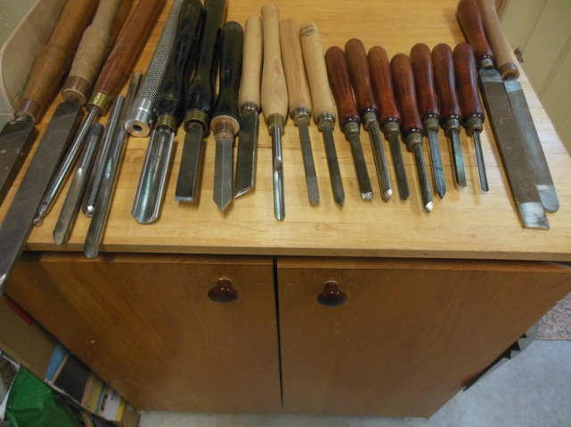

These tools are priced from $5 to $25

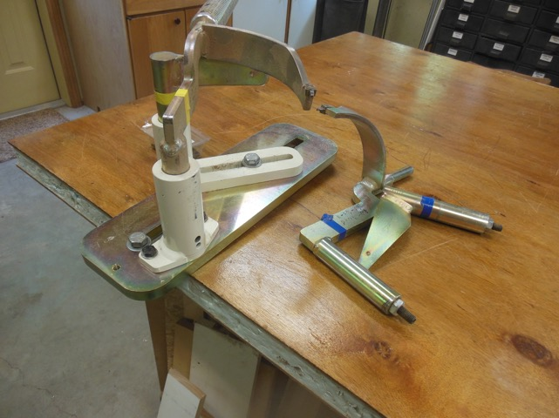
This is the Easy Core gear. There are two sets of cutters- 9 inch and 11 inch .$350.

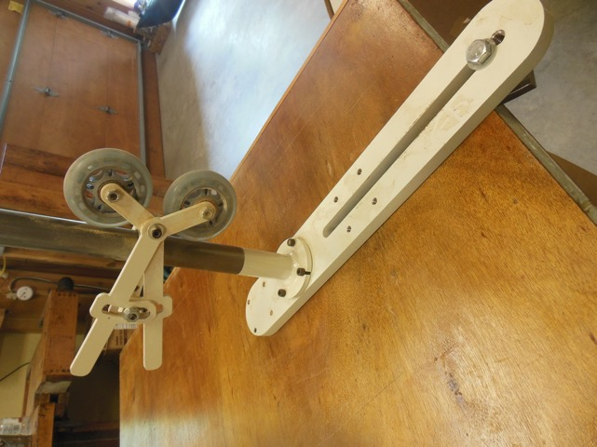

This is the bowl steady $80
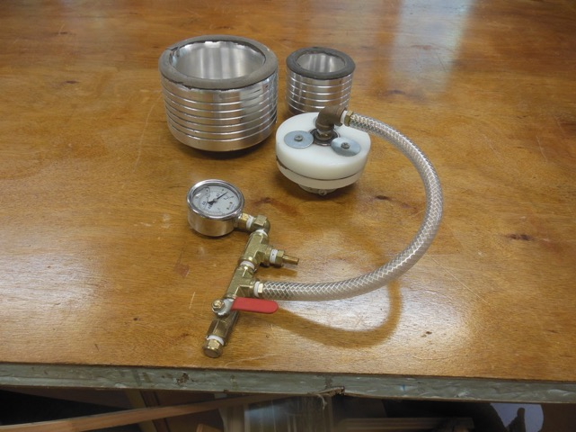
This is the vacuum chuck. $250.

Hi MWT,
I’m the guy who sits in a wheelchair down front at the monthly meetings. I have Parkinson’s Disease which not only limits my mobility, but also has caused me to give up bowl turning.
I have already sold my lathe ( Oneway 1640), but I have some important accessories to sell.
Specifically:
Oneway Easy Core system: with a swing base for the model 1640
9 inch knife set and an 11 inch knife set
also included a spare cutter and sharpening jig.
Oneway bowl steady.
Vacuum Chuck System: a rotary vacuum adaptor,
vacuum gauge manifold,
a 3.5 in drum,
a 5.5 inch drum.
It does not include a vacuum pump.
Sincerely ,
Cameron Weaver
Email address: cameroniweaver@gmail.com
Phone Number: 293-2667

